22.In pl/sql using raise application error with user Defined exception.

Create table:

CREATE TABLE employees (

employee_id NUMBER(10) PRIMARY KEY,

first_name VARCHAR2(50),

last_name VARCHAR2(50),

email VARCHAR2(100),

phone_number VARCHAR2(20),

hire_date DATE,

job_id VARCHAR2(10),

salary NUMBER(10, 2),

department_id NUMBER(10)

);

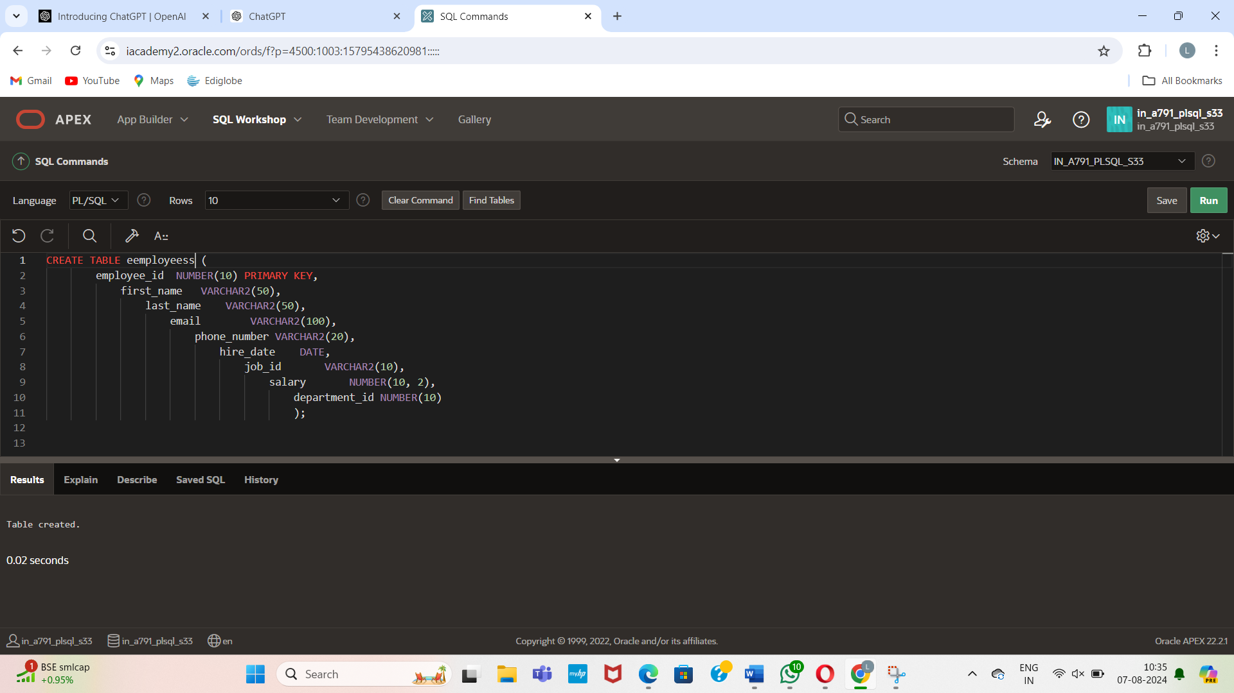

Insert values:

INSERT INTO employees (employee_id, first_name, last_name, email, phone_number, hire_date, job_id, salary, department_id)

VALUES (1, 'John', 'Doe', 'john.doe@example.com', '555-1234', TO_DATE('2020-01-15', 'YYYY-MM-DD'), 'IT_PROG', 60000.00, 10);

INSERT INTO employees (employee_id, first_name, last_name, email, phone_number, hire_date, job_id, salary, department_id)

VALUES (2, 'Jane', 'Smith', 'jane.smith@example.com', '555-5678', TO_DATE('2019-05-23', 'YYYY-MM-DD'), 'HR_REP', 55000.00, 20);

INSERT INTO employees (employee_id, first_name, last_name, email, phone_number, hire_date, job_id, salary, department_id)

VALUES (3, 'Robert', 'Brown', 'robert.brown@example.com', '555-8765', TO_DATE('2018-11-30', 'YYYY-MM-DD'), 'SA_MAN', 70000.00, 30);

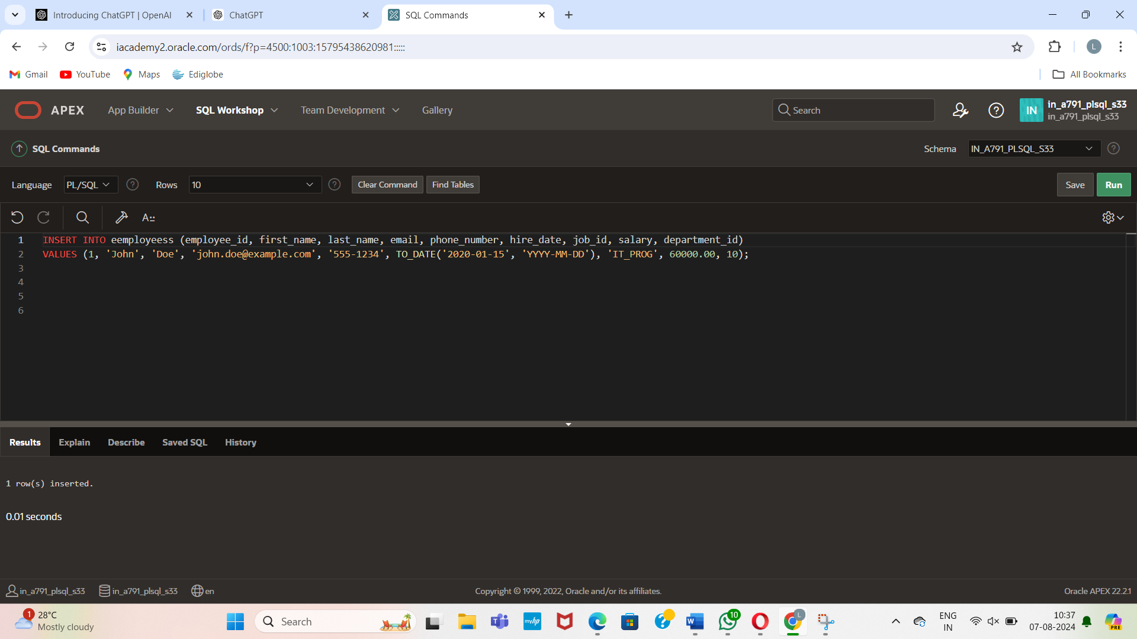

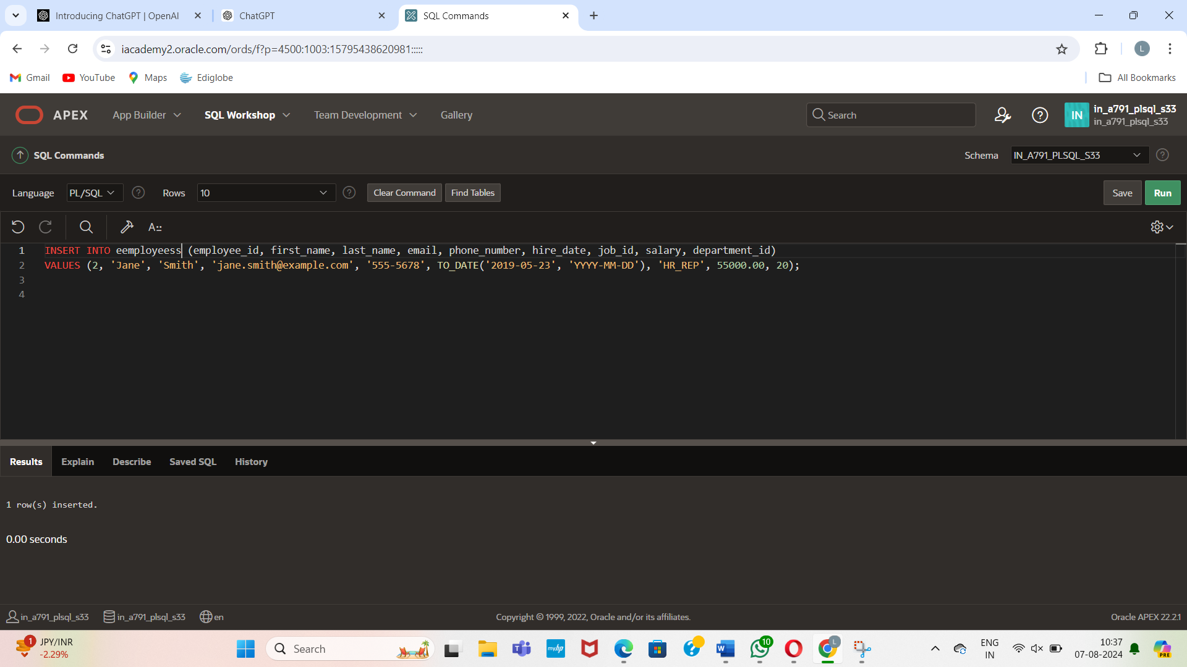

Declare:

DECLARE

e_name EXCEPTION;

PRAGMA EXCEPTION_INIT(e_name, -20999);

v_last_name employees.last_name%TYPE := 'Silly Name';

BEGIN

DELETE FROM employees

WHERE last_name = v_last_name;

IF SQL%ROWCOUNT = 0 THEN

RAISE e_name; -- Raise the custom exception

ELSE

DBMS_OUTPUT.PUT_LINE(v_last_name || ' deleted');

END IF;

EXCEPTION

WHEN e_name THEN

DBMS_OUTPUT.PUT_LINE('Valid last names are: ');

FOR c1 IN (SELECT DISTINCT last_name FROM employees)

LOOP

DBMS_OUTPUT.PUT_LINE(c1.last_name);

END LOOP;

WHEN OTHERS THEN

DBMS_OUTPUT.PUT_LINE('Error deleting from employees');

END;

/

